Hospitality Faithfulness Wholeness
Finance Assistant (Maternity Cover for Executive Assistant)

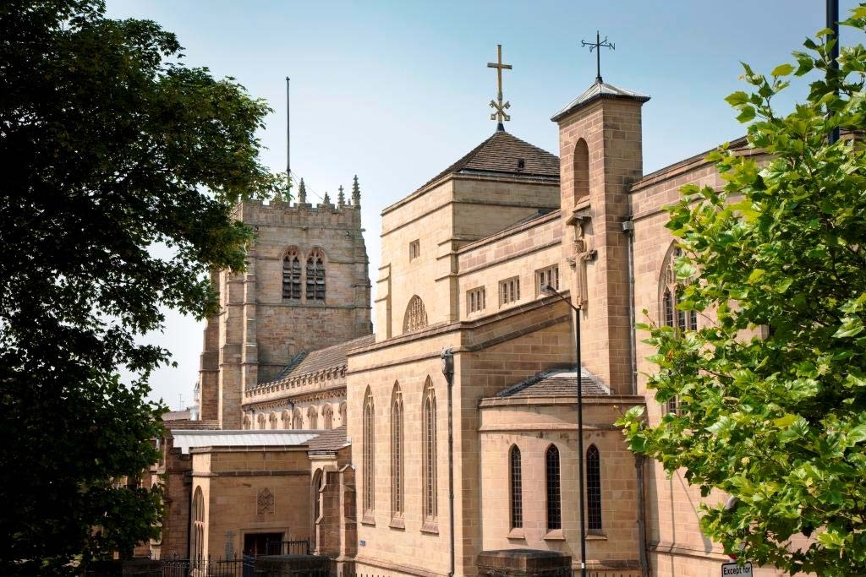

Role Responsibility

This post forms part of the administrative team of Bradford Cathedral. Its goal is to provide operational support to the Director of Finance so that they can focus on the strategic activities required by Chapter and governance activities required by statute.

The role is to cover part of the duties of the Cathedral’s Executive Assistant during her period of maternity leave. As a result, this will be a fixed term appointment, initially for a period to the end of December 2022. The post may be extended into 2023 depending on availability of finance and the return date of the Executive Assistant.

A successful and competent Finance Assistant is essential to the efficient running of this team and its attainment of the Cathedral’s strategic goals.

Main Duties

- To provide operational support to the Director of Finance.
- To manage relationships with the relevant contractors and suppliers.
- To undertake small projects as directed by the Director of Finance.
- To process monthly accounting journals to clear control accounts.
- To reconcile Cathedral control accounts (including but not limited to Pay, Tax, Pension and Credit Card).
- To perform monthly bank reconciliations if required (this role is usually carried out by a volunteer but the finance assistant may be tasked with this in the case of lack of availability of the volunteer)
- To stand in for the Cathedral Secretary to ensure the Cathedral's payments and payroll continue to operate during holiday periods (i.e. to provide greater resilience).
- To support the production of monthly management accounts by checking transaction detail and reporting to the Director of Finance
- To reconcile income accounting systems (including ChurchSuite, eventbrite, donor and EMS) to income received.
- To adhere to all of the Cathedral’s policies and procedures.
- To carry out any other duties commensurate with the role, as approved or directed by the Dean and C.O.O.

Person Specification

The successful candidate will have:

REQUIREMENTS | ESSENTIAL (E)  DESIRABLE (D) | MEASURED BY:  A – Application  D – Documents  I – Interview  R –References
Qualifications
Degree level qualification or equivalent professional qualification. | D | A/D
Good literacy and numeracy skills (GCSE Maths & English) | E | A/D
Skills
Excellent verbal and written communication skills | E | A/I
MS Office Packages (Word, Excel, Powerpoint) minimum intermediate level. | E | A/I
Calm and well mannered. | E | I
Highly organised and methodical with the ability to prioritise effectively. | E | A/I
Resilient and able to work under pressure. | E | I
Project Management | D | A
SAGE Accounting Package Experience | D | A
ChurchSuite CRM Package Experience | D | A
Ability to hit deadlines. | E | A/I
Experience
Recent experience of working in a finance team. | E | A
Experience working in the not-for-profit sector. | D | A
Knowledge
A working knowledge of the Church of England and the Christian faith. | D | A/I
A good understanding of GDPR. | D | A
Attitudes
Honesty, integrity and strong values. The appointee needs to be able to work comfortably in a faith-based organisation and be sympathetic to, and supportive of, Christian values. | E | I
A wholehearted commitment to the success of the Cathedral. | E | I
The willingness to work flexible hours on occasion, with periods of considerable intensity, as required. | E | I
Ability to work collaboratively as part of a team however equally comfortable working on their own. | E | I/A
Ability to show tact, diplomacy and discretion. | E | I/A

Terms and Conditions

This post is based at Bradford Cathedral. There is some flexibility of hours and the days that are worked however we would expect the post holders normally contracted hours to be worked between 08:30 – 17:00. Occasionally, it may be necessary to work outside of these hours including evenings and weekends.

The post is a Part Time Post and is based on a 7.5 hours per week. Attendance is required at the Cathedral as agreed with your line manager in advance.

The post is line managed by the Director of Finance.

The remuneration for this role is £5,070 per annum/ £13 an hour. Annual leave for a Full Time post is 28 days per year plus 8 bank / public holidays. This post is 0.2 of a Full Time post. Therefore, the annual leave for this post is 7.2 days including bank holidays.

This post is initially until 31 December 2022, however there may be a possibility of this being extended.

Chapter will contribute an amount equal to 5% of salary towards a Pension Scheme run by the Church of England and a further 3.5% is added from the employee’s salary.

The first six months of employment will be a probationary period during which the employment may be terminated by either party on giving the other notice of one month. Thereafter notice is three months on either side.

An induction and all appropriate health and safety training will be provided.

Bradford Cathedral is committed to safeguarding and promoting the wellbeing of all people and expects all staff and volunteers to share this commitment. An offer of employment is made subject to pre-employment checks and a confidential safeguarding declaration.

How to Apply

Please apply using the Church of England’s Pathways website;
https://www.cofepathways.org/members/modules/job/detail.php?record=4584

The deadline is 9.00 a.m. on Wednesday 3 August 2022. For an informal discussion about the post please contact the Director of Finance, Simon Dennis – simon.dennis@bradfordcathedral.org

The Interview Process
Interviews will take place on Monday 8 August 2022 at Bradford Cathedral.

The Cathedral

In 2019 the Church of St Peter, Bradford celebrated its centenary as a Cathedral although there has been a Christian church on this hillside for at least 1,200 years. In 2014 it became one of three Cathedrals in the newest diocese in the Church of England – Leeds. Wakefield and Ripon being the other two. It was also made the first eco Cathedral in the Church of England in 2010.

This is an inner-city Cathedral in one of the poorest cities in the UK. The parish ranks 475 out of 12,382 where 1 is the most deprived parish. This means that the parish is among the most deprived in the country.

The Dean is Vicar of Bradford and the Cathedral is an important focus of Christian witness in the centre of the City.

The Cathedral Council, College of Canons and Chapter currently make up the ‘body corporate’ and the congregation is represented on each grouping and has its own Community Committee. This governance arrangement is due to change under the new Cathedrals Measure which will be implemented during 2022-3.

This year we will also welcome a new Dean to the Cathedral and undertake work to develop a new forward strategy. Our current strategic framework cites the following as our Purpose, Values and Strategic Aims;

Purpose

“Serving Christ and transforming lives through welcome, worship and encounter.”

Values
Hospitality Faithfulness Wholeness.

Strategic Lines
- To encounter God
- To nurture faith and gifts
- To grow a healthy organization
- To resource the Church
- To enrich city life
- To achieve financial sustainability
- To conserve and develop the heritage
- To respond to human need
The staff team is committed, energetic and supportive. Over the last few years, through good financial management and use of grant income, the team has expanded and is continuing to grow.

Being in the centre of the city we are proud of the peace and beauty of the Cathedral Close and visitors often comment on the precinct and warmth of the Cathedral. In the summer people enjoy the grounds in their lunch hours.

