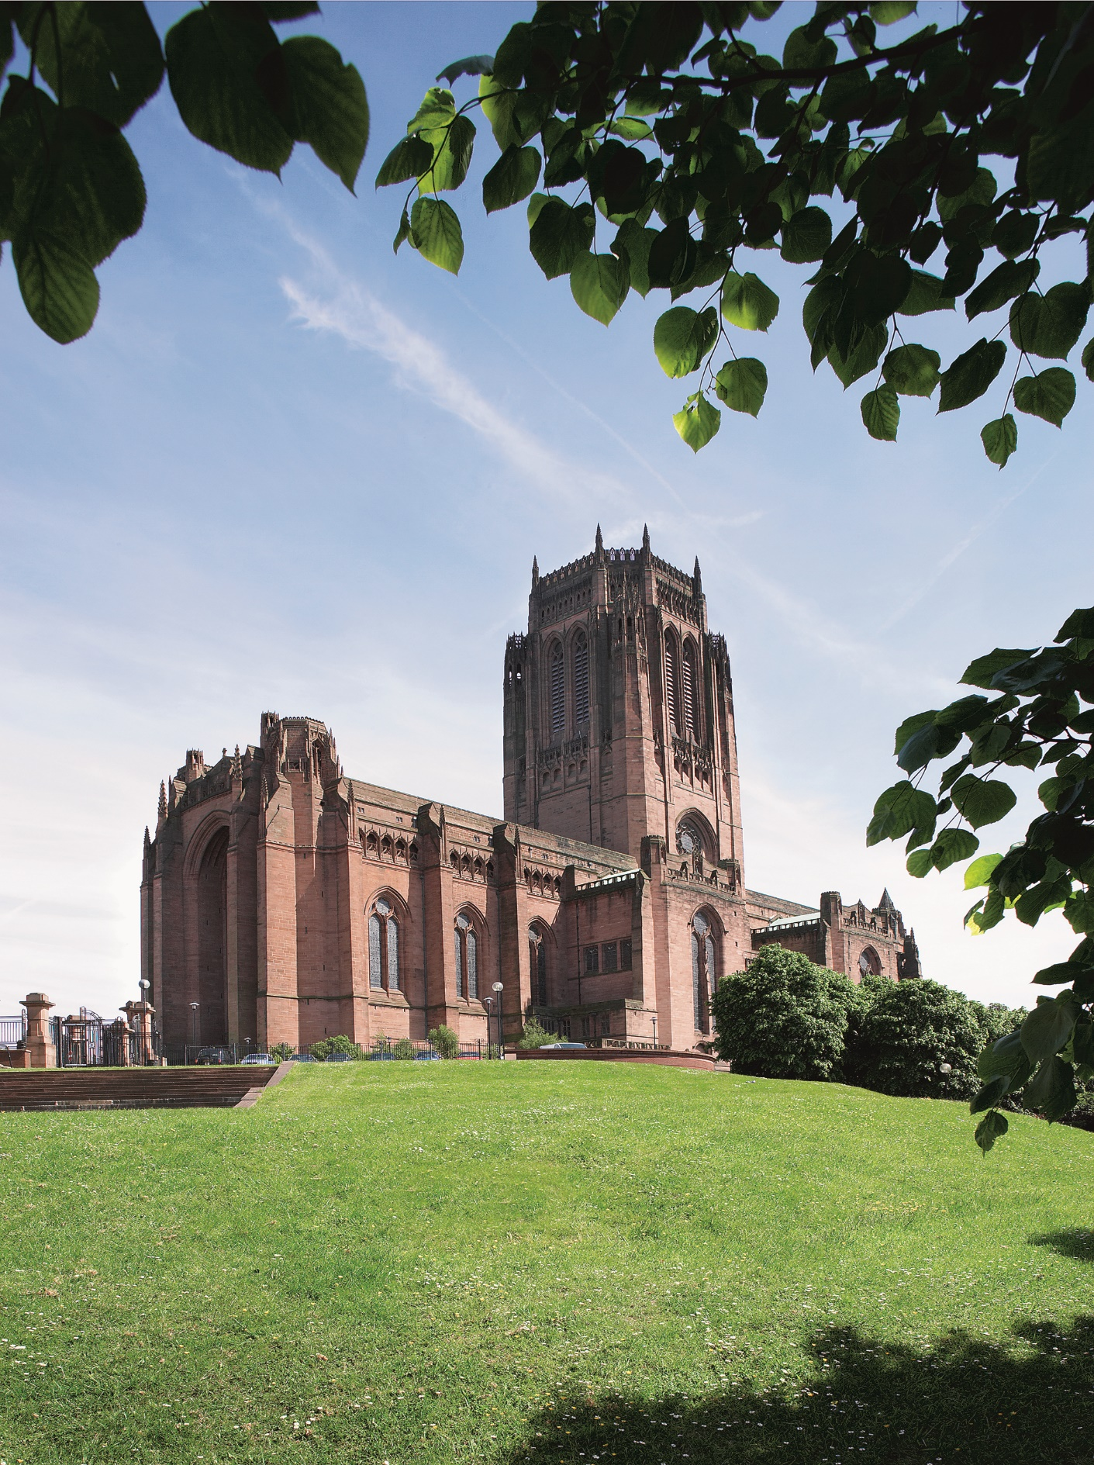

Schools Singing Leader  
Information for Applicants

Contacts for Enquiries  
Stephen Mannings

[Stephen.mannings@liverpoolcathedral.org.uk](mailto:Stephen.mannings@liverpoolcathedral.org.uk)

(0151) 702 7291

Encounter Liverpool Cathedral

Liverpool Cathedral is a place of spiritual and cultural significance for the city and region of Liverpool. From its foundation in the early part of the 20th century it has existed as community and building built by the people, for the people to the glory of God.

Liverpool Cathedral is more than an iconic Grade 1* listed building. It’s a vibrant, active place that the people of the city, regions and world encounter in many ways. So alongside those who come for one of our daily worship services, people may encounter us for a gala dinner or a school trip. A tourist may visit us or we could be hosting an awards ceremony or graduations. People encounter us in many ways. But in each way, we hope they encounter a warm welcome and sense of God.

As part of their visit we believe everyone will encounter:

* Inspiring Christian worship
* A breathtaking experience
* A community committed to justice and mercy
* A safe, generous place in joy and sorrow
* A dynamic community of staff and volunteers
* A God who knows and loves you.

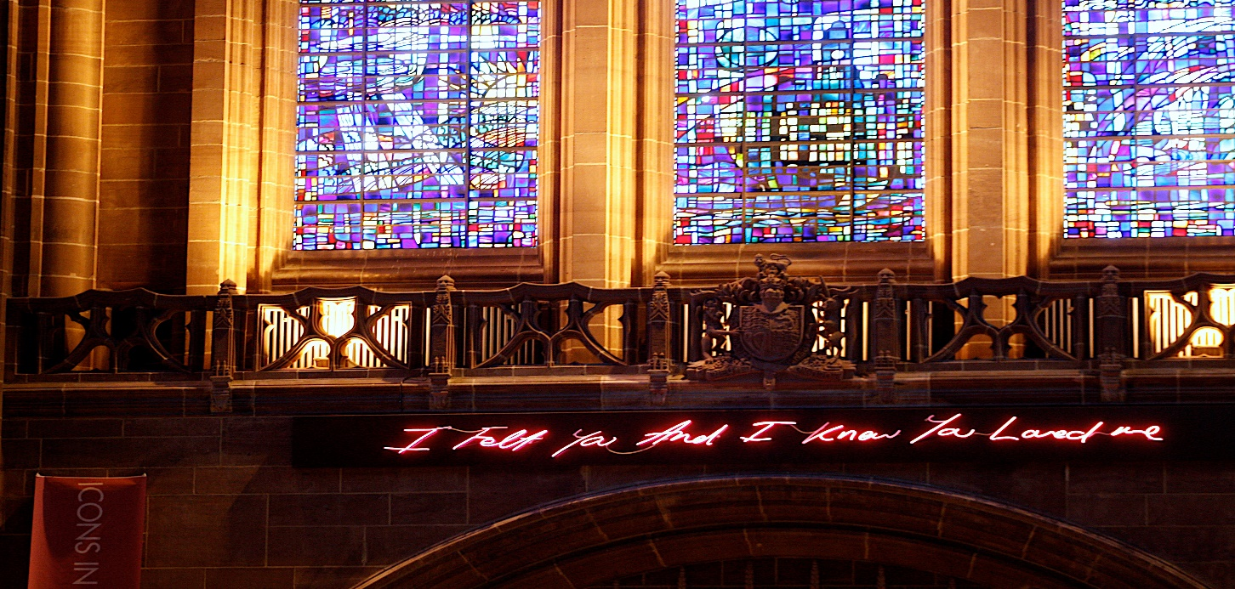Working for Liverpool Cathedral will bring you into a community that seeks to make those encounters happen. You will be someone who can subscribe to, and live out, our values of excellence, dynamic, integrity and inclusive. You will have the benefits of working in a landmark building with colleagues who are serious about the work life balance with generous holiday allowances and access to an Employee Assistance Programme. We have a strong working partnership with the Diocese of Liverpool bringing extra support to our activities.

For more information about Liverpool Cathedral [www.liverpoolcathedral.org.uk](http://www.liverpoolcathedral.org.uk)

Liverpool Cathedral Values

Our values underpin the culture of working for Liverpool Cathedral, they are:

**Integrity:**This means we act honourably and truthfully and display consistency of character. We show respect to all recognising how we speak and act affects others. We uphold high standards and are accountable for our behaviour.

**Inclusivity:**This means we actively co-operate with one another and value our differences and solve problems by listening and finding solutions together, always treating everyone fairly and promoting participation. We create a culture of warmth and belonging, where everyone is welcome.

**Excellence:**This means we go that ‘extra mile’ and follow through on our commitments and consistently deliver the highest quality of service to all. We demonstrate professionalism and have high expectation of each other being committed to teamwork, sharing knowledge, resources and skills.

**Dynamic:**This means we actively embrace change, welcome progress and display enthusiasm, passion and enjoyment for our work. We are innovative, open minded and willing to adapt; and we use our drive and commitment to energize, engage and inspire others



Music at Liverpool Cathedral

Liverpool Cathedral is renowned for being among the first in the world to offer musical engagement opportunities to people of every age, from new-born upwards. This manifests itself in the provision an early-years music education programme, a Schools Singing Programme, a junior choir, youth choir and adult community choir as well as the traditional Cathedral Choir which provides music at 7 choral services each week during choir term, including services at key points in the liturgical year.

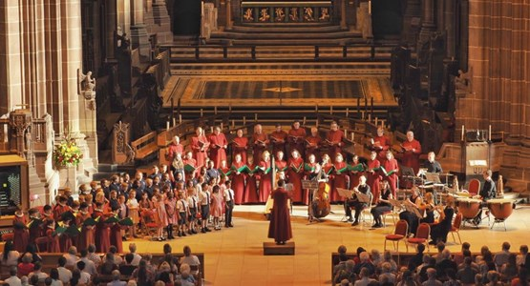The Cathedral Music Department comprises a Director of Music, Cathedral Organist, Associate Organist, Liturgy & Music Administrator, Assistant Choral Director, Choral Outreach Lead, Choral Scholars and Organ Scholar. These are in addition to a large team of volunteer Choir Guardians and parent supervisors.

Role of a Schools Singing Leader

A Schools Singing Leader (SSL) will be a musician with formidable skills when it comes to teaching group singing to children of primary school age. They will work closely with the Choral Outreach Lead within the music department of Liverpool Cathedral and be line-managed by the Director of Music.

The SSL will work primarily on the delivery of the Schools Singing Programme running weekly singing classes in primary schools. They will also take on the responsibility of working on, or leading, one of our borough-based Junior Choirs.

SSL candidates will have experience of teaching group singing to primary and/or secondary school age children in a school, church, cathedral, or other similar setting. The individual will develop music within the diocese of Liverpool, inspiring and nurturing potential in young people, increasing awareness of Liverpool Cathedral and its musical tradition.

The Liverpool Cathedral Schools Singing Programme was established in 2012. As of 2025, it works with 25 partner schools across the diocese. These schools are made up of both Church of England and non-faith schools.

Liverpool Diocese and Cathedral are committed to treating our whole community with dignity and respect. We desire to represent diverse identities within our community whether this be by race, culture, religion, sexual orientation, gender, disability or social background of each person to ensure they fulfil their potential within a proactive, loving and caring environment.

**Delivering Workshops with the Cathedral Schools Singing Programme**

* To work within an agreed framework for session content as agreed by the Choral Outreach Lead and Director of Music
* To build relationships with CofE and non-faith schools, across the Diocese, encouraging them to sign-up to long-term engagement with the Cathedral Schools Singing Programme.
* Once a term, the SSL will deliver whole school singing assemblies in a variety of schools (which may or may not include those which they’re assigned to weekly) as a means of engaging all the pupils and staff, in addition to the ones we work with on a weekly basis.

**Working on or leading one of our Junior Choirs**

* We currently have Junior Choirs in Knowsley, Liverpool, and Sefton. These choirs serve the boroughs within which they are based. The SSL will lead or work with one of these after-school choirs which rehearse once per week.
* The SSL would be responsible for music selection, rehearsing, and general administration of the choir to which they’re connected.
* To build relationships with churches across the Diocese through our partnering with them to plant new borough-based Junior Choirs.

**Recruitment of Choristers for the Cathedral Choir**

To assist, where necessary and practical, with the annual recruitment activities for new boys and girls to become probationers in the Cathedral Choir (normally in the summer term).  The post holder will undertake other relevant duties as may be requested from time to time and commensurate with the role.

We are looking for musicians with a formidable set of skills which enable them to deliver high-quality, fun, and engaging singing sessions in our primary schools, with a focus on training young voices to a high standard. It is expected that the applicant will have solid piano/keyboard skills, sufficient to accompany whichever class or assembly they are leading, and preferably a good level of sight-reading ability. You'll need to have a car and full driving license. Having a degree in music is desirable, although not essential.

**Terms and Conditions**

**Salary**

£13,545

**Contract**

This is initially for a 2-year fixed term contact.

**Hours of Work**

**20 hours per week for 40 weeks of the year. Per week this works out as:**

10 hours contact time in schools

2 hours Junior Choir

6 hours admin and planning

2 hours travel between schools.

**Location**

Anglican Cathedral Church of Christ, St James Mount, Liverpool, L1 7AZ

**Annual leave**

25 days plus eight bank/public holidays pro-rata to be taken outside of term time.

**Other benefits**

There are a range of other benefits including non-contributory pension scheme with generous employer contributions (additional voluntary contributions may be made), Employee Assistance Programme giving you 24-hour access to support for your health and wellbeing, a supportive culture with core values of Integrity, Inclusivity, Dynamic and Excellence, employee discount in Cathedral shop and bistro, free on-site parking, secure bike storage and easy access to public transport. Mileage reimbursement for work related travel at 45 pence per mile.

**DBS Check**

The post holder will require an enhanced disclosure and barring service check.

**How to Apply**

Application for this role is through Pathways

The closing date for all applications is 18th May 2025

Please note that the information you provide in your application will be used only for the purpose of recruitment and selection and will be held in accordance with the Data Protection Act 2018.