**Welcome to the diocese of Newcastle!**

Thank you so much for your interest in this role, and I hope you enjoy reading the information contained in this brochure and will find it helpful for your discernment. These are exciting and challenging times in the Diocese of Newcastle. Exciting because we are at an early stage of a new season, challenging because like many dioceses we face conversations about our future and how best we use and deploy our resources. Our Deanery Development work has engaged every parish and benefice in renewed conversations about mission and ministry, and we are in a process of entering a new phase in that work, mapping out our renewed strategy and vision. Our outward facing values of ‘seeking, sharing, sending’ stem from a commitment to be a Church turning outwards in mission and ministry, and younger and more diverse by: **SEEKING** through being open to God’s transforming love; **SHARING**through being generous with God’s transforming gifts; **SENDING** through being engaged in God’s transforming work in the world. I am looking for clergy who are excited about the opportunities and challenges we face, who are happy to work collaboratively and imaginatively with colleagues, and who can inspire communities to roll up their sleeves and get stuck into God’s mission, by affirming, enabling, and encouraging lay and clergy together. As your Bishop, I am committed to your wellbeing and development, and I would love to explore with you whether God may be calling you to this role.

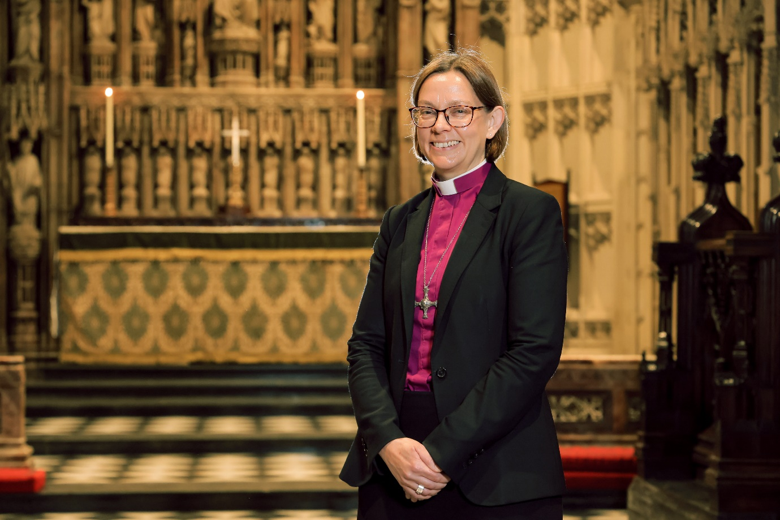

**The Rt Revd Dr Helen-Ann Hartley**

**Bishop of Newcastle**

The Diocese of Newcastle is the Church of England’s most northerly diocese. This Diocese in the ‘land of the Northern Saints’ was formed in 1882 and comprises **169** parishes across **2,110** square miles. The Diocese covers the local authorities of Northumberland, Newcastle, North Tyneside and also small parts of County Durham and Cumbria. The **12** deaneries within **2** archdeaconries serve a population of about **831,600** people across a variety of communities ranging from sparse rural to large inner-city areas of deprivation.

