Associate Vicar: Christ Church Barnston with St Michael's Pensby

The parish
We are a gospel-centred, bible teaching Anglican church, one parish with two sites serving semi-rural and suburban environments on Wirral. The parish comprises some sixteen thousand people in the two distinct residential areas of Barnston and Pensby, with their own communities, culture and opportunities. Many good schools are easily accessible, with five primary schools in the parish itself.
The Wirral peninsula is a fantastic location, with many areas of natural beauty, beaches and places of interest. Situated between the Rivers Mersey and Dee it is close to vibrant Liverpool, historic Chester, and in easy reach of north Wales.

The church
Our church family consists of approximately two hundred adult members and thirty children and youth. We have people of all ages, and whilst we currently tend towards an older profile, there is huge potential for outreach to families with some established and thriving work already in place. We have previously enjoyed the ministry of Associates and for the past seven years, a youth and families worker, however, having recently sent him and his family to serve in Kenya, younger generations and families ministry is a priority area for investment, especially building teams to support parents, nurture and reach out. The staff team currently comprises the Vicar, discipleship coordinator (biblical counselling lead) and parish administrator, assisted by the wardens, PCC, volunteer leadership, retired clergy and lay readers.
Christ Church Barnston is the parish church and has been at the heart of the local community for some 150 years. The former school room now functions as the church hall which also houses the parish office and work-space for the staff team. There is huge potential for development to make the site a focal point of community life. Whilst the campus is set apart from the main residential area, it is situated on the busy Barnston Road and is a well-known landmark. Many local families have connections with the church.
With expanding housing development in Pensby, St Michael's was built in the 1950s to reach the new community. It now comprises a recently reordered church building with a foyer/cafe area connected to a large modern hall. St Michael's enjoys an opportune location by the crossroads at the centre of Pensby. Both parish buildings have good facilities: toilets, creche rooms, audio-visual equipment, disabled access, super-fast wifi, etc.
The church family is warm and welcoming, with a desire 'to make Jesus known and to grow together in Him.' This is an exciting time to join the team and to serve alongside the church family to these ends. With the arrival of a new incumbent two years ago, we are in the process of refining our vision, giving particular attention to how we live and grow as disciples across the generations; and how we might engage further with our local community. We are working towards implementing a 'gospel community' approach, sharing life in smaller groups to spur one another on in everyday discipleship and mission, being salt and light as gospel communities engaging our local community. We are serious about mission extending from our doorstep to the uttermost parts of the world, with a relational approach to our five mission partners.
Our priorities are:
- Commitment to Jesus (centred on the gospel)
- Community in Jesus (united in the gospel)
- Commission of Jesus (intentional for the gospel)
- Compassion like Jesus (shaped by the gospel)
We are an active church, with a busy and varied ministry and outreach across the ages, generously served by many able and committed volunteers.
Our current service pattern comprises a more traditional 8:30am BCP Holy Communion, our main church family gatherings are at 10:30am at both Christ Church and St Michael's, with a 5:30pm evening service and a midweek 10:30am communion service taking place at St Michael's.

The role
The Associate Vicar will work with the staff and ministry teams, helping to shape and deliver the life and ministry of the church family, playing a full part as a stipendiary ordained minister in the parish. Our aim is to work collaboratively, helping one another work out the ministry of the church. The Associate Vicar will also take part in the life of the Diocese of Chester.
There is some flexibility to role, we want the Associate Vicar to have the freedom to serve according to the particular gifts, experience and passions they bring, whilst recognising the needs of the parish for someone who can:

- Take a leading role in pastoring the St Michael's 10:30am congregation.
  - e.g.
  - leading the team to organise the St Michael's gathering.
  - preaching and leading, helping also to nurture the ministry of lay-members
  - serving with the volunteer team to deliver pastoral care (across the parish but with an emphasis on the Pensby end).
  - working with the Vicar and Mission Leadership Team to develop vision and strategy, especially around gospel communities.
  - helping St Michael's realise missional potential.
  - encouraging the gifts and ministry of others.
  - taking occasional offices across the parish.
- Help to develop and oversee ministry amongst younger generations.
  - e.g.
  - recruiting and equipping children and youth ministry teams across the parish.
  - developing support for families raising children in the faith.
  - developing outreach opportunities, existing and new. *
  - building relationships with local primary schools.
  - working with the PSO to deliver good safeguarding culture and practice.
* In addition to the organic, everyday mission, we currently have a thriving toddler group, monthly Messy Church, regular family activities, weekly youth group (small), weekly Sunday activities from 3yrs+, annual holiday club, school assemblies, etc.

We are looking for someone who...
Necessary
- is passionate about Jesus and growing in their own discipleship.
- has proven leadership experience.
- is committed to, and has experience of, regular bible teaching in a range of contexts.
- is prayerfully dependent.
- is approachable, with a warm pastoral heart and can relate across a broad spectrum of people.
- is able to serve respecting the breadth of theological conviction across the parish.
- has a sense of humour.
- has a concern for the unreached with a willingness to engage in the life of the local community, understanding the local church to be God's prime agent for mission.
- seeks to live out the bonds the gospel creates, with an intergenerational vision for church life.
- takes a collaborative approach, able and eager to work with and inspire others.
- has grown, encouraged and equipped leaders and volunteer teams.
- is a self-starter, able to manage a healthy work-life balance.
- proactive in helping to foster a safeguarding culture.
Desirable
- brings experience of ministry amongst younger generations.
- is able to engage with digital platforms.
- is administratively efficient with an eye for detail.

We require applicants to exemplify the sort of participation in church life that we ask of everyone who belongs to the church family, such as involvement in small groups, praying for the church, exercising hospitality and having an outward-looking mindset.

Package
- The Associate Vicar will be responsible to the Vicar, with an appropriate support team. The post will be held under Common tenure as a Locally Supported Minister, for an initial period of 3 years (with the potential for extension).
- The post will attract a stipend and pension provision as set by the Diocese of Chester for an Associate Vicar. Council Tax, water and broadband fees will be paid by the parish. Expenses will be paid by parish in line with Diocesan policy.
- A stipendiary post requires a working week of 48 hours over 6 days, including evening work, with an additonal 24hr rest period to be taken monthly. The Associate Vicar is entitled to 36 days annual leave (no more than 6 Sundays), bank holidays. In addition to time allowed for continuing ministerial development, leave may also be given for conferences, retreats, camps, etc.
- Accommodation is provided, we have a well-proportioned four-bedroomed semi-detached house in a desirable location near St Michael's (Antons Road), including a kitchen-diner with adjacent utility room, two further reception rooms, downstairs toilet, an ensuite bedroom, modern bathroom, outside storage, garden, etc.
- The appointment is subject to an enhanced DBS check and three references (one being a relevant church leader and one from your Diocesan Bishop).
- There is an occupational requirement for the role-holder to be a male Christian. The PCC has made a request to the Bishop, on grounds of theological conviction, that arrangements be made for it in accordance with the House of Bishops’ Declaration on the Ministry of Bishops and Priests (concerning women priests). The theological conviction in question concerns the priority of maintaining the unity of the body given the range of views held respectfully and peaceably within the church family, we invite applications from candidates sensitive to that diversity, whatever their personal conviction.
- Apply via Pathways, deadline 17th May 2024
- Interview date: Thursday 30th May 2024
- Start date: ideally September 2024 (with the potential for some flexibility if required)

If you have any questions, require further information, or would like to speak to someone informally, please contact the Parish Office (9:30am-2:00pm Mon.-Fri.) 0151 648 2404 or email the Vicar at slater.cr@me.com.
Thank you for taking the time to read this description, we would like to wish you every blessing as you discern where the Lord would have you serve. We are eagerly looking forward to serving alongside the successful candidate, please be assured of our prayers as this role is advertised.

www.barnston.info

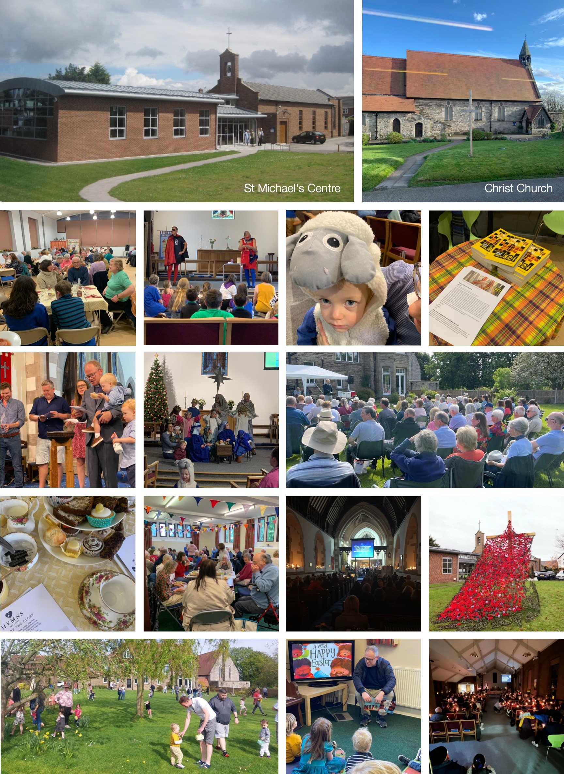
St Michael's & Christ Church family life

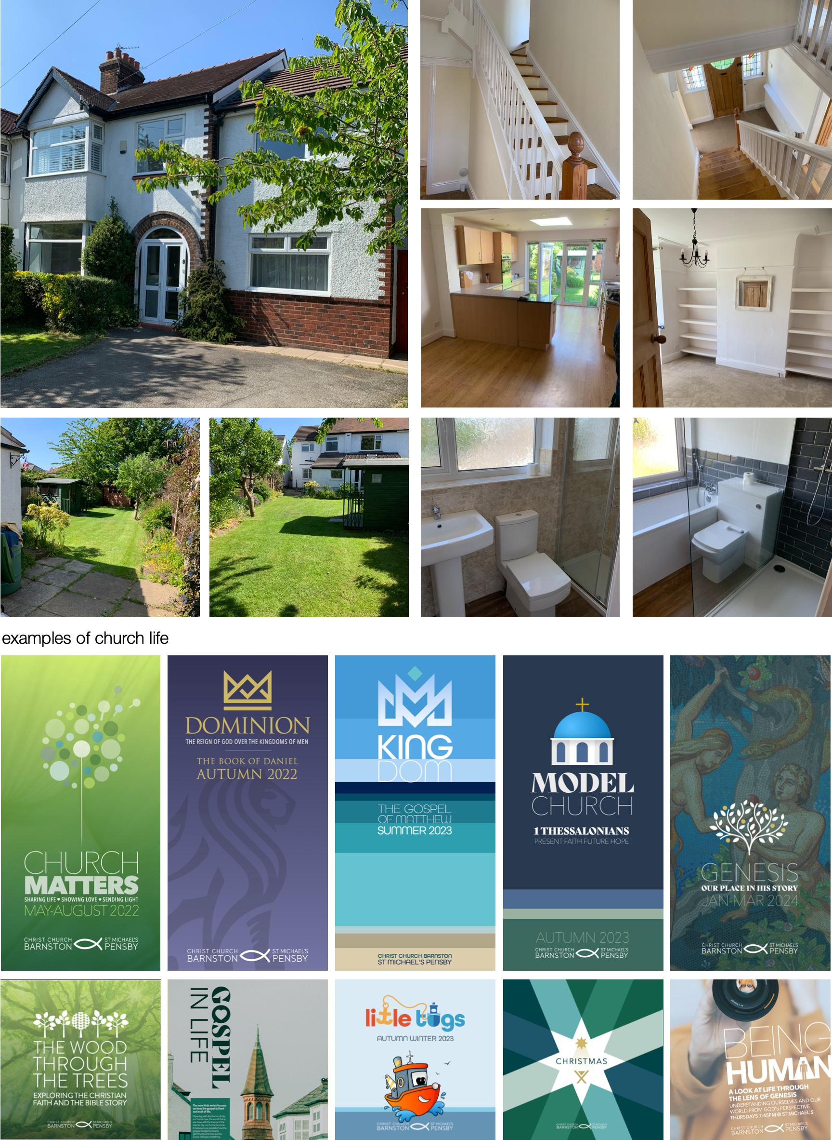
Antons Road accommodation

