

**The Diocese of Manchester**

**PARISH INFORMATION AND PROFILE**

**The benefice or parish of:**

**Prestwich, St Hilda Church**

**………………………………………………………………………………….**

**Please return your Parish Profile when complete, together with any other requested papers, to:**

***The Bishop of Manchester*** [*bishopmanchester@manchester.anglican.org*](mailto:bishopmanchester@manchester.anglican.org)

***The Suffragan Bishop*** [***bishopmark@manchester.anglican.org***](mailto:bishopmark@manchester.anglican.org)

***The Bishop of Beverley*** [*office@seeofbeverley.org.uk*](mailto:office@seeofbeverley.org.uk)

***The Archdeacon*** [*rachelmann@manchester.anglican.org*](mailto:rachelmann@manchester.anglican.org)

***The Registrar*** *St John's House, 155-163 The Rock,*

*Bury, BL9 0ND*

***The Patron – if applicable Bishop of Manchester &   
Maryrose Thompson***

***The Area Dean*** [*colinpearson@manchester.anglican.org*](mailto:colinpearson@manchester.anglican.org)

***The Deanery Lay Chair***

**A hard copy needs to go to the Registrar. Otherwise email copies suffice**



**1. INTRODUCTION**

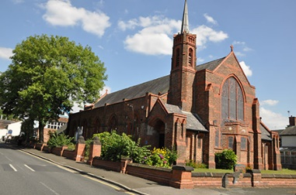

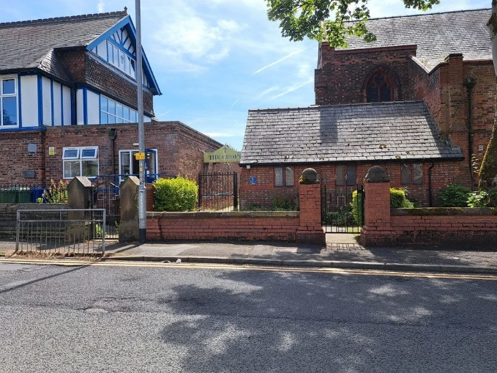

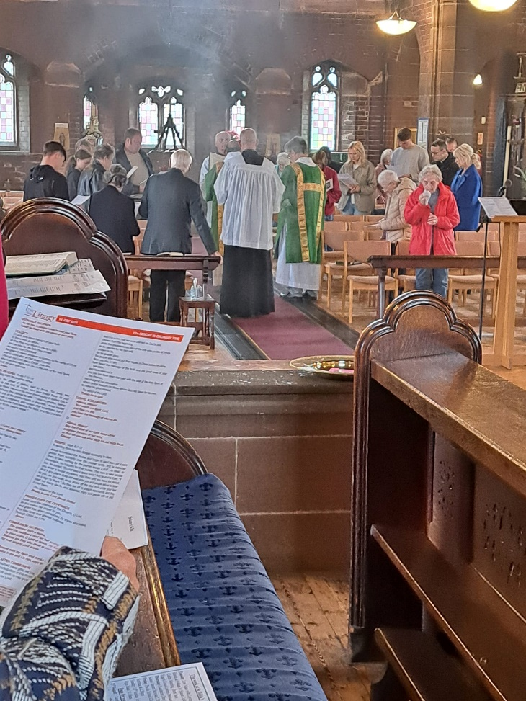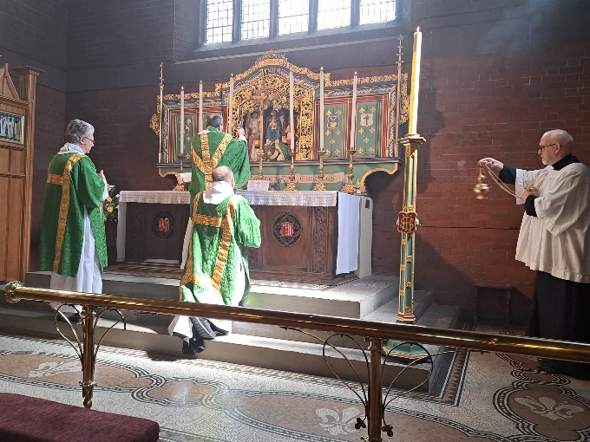

Saint Hilda’s is a church where its faith is firmly rooted in the Catholic tradition as lived out in the Church of England, we do this by following the traditions and the teachings of the Church within the liturgy, gospels, faith and in our actions.  
Our aim is to do this by being a welcoming and inclusive church   
• to take and share our Faith beyond the church door and into the community   
• to grow in faith and help others to do the same

• to acknowledge the past, respond to the present and prepare for the future,   
• to foster and encourage participation in Parish life through worship and activities.

We are located within the Heaton Park Area of Prestwich, which is an urban area near to the green space of Heaton Park. Here, we proudly proclaim our faith by the love of God and of his son Jesus Christ. We serve this area diligently by helping the community by love, faith and action.

We look forward to welcoming the appointment of a new priest to guide us as we journey together as a Parish. We pray that the appointment will be a man who is also deeply rooted in the Catholic faith, who can guide us through the celebration of the liturgy and all that it encompasses. A man of prayer, someone who is willing to be a hard worker, to take a lead on all the challenges that we may face as we build on the future of our church and the Parish School in the Catholic way of life.

2. BASIC INFORMATION AND STATISTICS

2.1. Full name of benefice or parish(es)

Benefice of St Hilda, Prestwich

2.2. Title of the post that is vacant

Interim Parish Priest

2.3. Name and address of patron (if the Bishop of Manchester, write “Bishop”)

The Lord Bishop of Manchester

Maryrose Thompson of 9 Blackburn Street, Prestwich, Manchester M25 1FT

2.4. Archdeaconry, Deanery, and name of Area Dean

Please include the contact details (phone and email) of the Archdeacon and Area Dean.

Archdeaconry Bolton

Archdeacon The Ven Dr Rachael Man

[**rachelmann@manchester.anglican.org**](mailto:rachelmann@manchester.anglican.org)

Deanery Bury and Rossendale

Area Dean **The Revd Donna Williams**

[donnawilliams@manchester.anglican.org](mailto:donnawilliams@manchester.anglican.org)

2.5. Official clergy housing:

The Diocese will provide a suitable four-bedroomed parsonage for the successful candidate.’

2.6. Official population:

**The 2021 census population for Prestwich 3,250**

2.7. Number on electoral roll

**The electoral roll has 48 members**

2.8. Average Weekly Attendance for the last 3 years

**Over the last 3 years the Sunday Mass average weekly attendance is between 34 to 42 people each Sunday.**

2.9. Average Weekly Attendance of children and young people under 16

**Over the last 3 years the Sunday Mass average weekly attendance is between 3 to 7 young people/children.**

2.10. In the last twelve months, numbers (if applicable) of:

**a. Those baptised = 6**

**b. Those confirmed = 2**

**c. Marriages = 1**

**d. Funerals = 6**

**e. Christmas communicants (all services) = 71**

**f. Easter communicants (all services) = 46**

2.11. Anglican churches and licensed places of worship in the benefice or parish (es) profiled here

a. Name of principal church

**Prestwich, St Hilda**

b. Approximate key dates for the building

The history of St Hilda began over 200 years ago with the construction of a Day School which stood on the site of the Station Lodge entrance to Heaton Park. An Infant school was built in 1840. This small school continued until 1879 and a new one was built which was designed to cater for both school and church purposes with the East end having a Chancel. In 1887 a temporary ‘Iron Church’ was constructed adjoining the school. The Chancel Fixtures were transferred from the school and moved to the Iron Church. This structure had not long been in place before it was enlarged and could provide seating for 260 worshippers. The Iron Church became the spiritual home of the people of the district, but eventually a permanent Church was considered a necessity.

St. Hilda’s church was dedicated on 3rd October 1903. The main portion of the building was completed, and on Saint Luke’s Day, 18th October 1904, the Church was consecrated by the Lord Bishop of Manchester, the west end and vestry were of a temporary construction and remained so until 1922.

A boundary wall and carved oak gates were added and a permanent West end structure, with North and South porches and Baptistry were added. The main fabric of the building had remained unchanged and continues to provide a place for those of the Anglo-Catholic tradition of the Church of England.   
The Croft (the new hall) was built in 2017 and a reordering of the vestries was needed, this marks a new beginning and a great opportunity to build on the faith and determination of those who brought this Church into being and is part of our legacy for the future.

c. Approximate seating capacity

**330**

d. When was the last Quinquennial inspection done? What are the main things that the architect has highlighted as needing doing? How much did the architect estimate they might cost? What progress has been made thus far by the parish?

The last inspection was carried out in **2022**

A copy of the QI report is available to view.

e. Name of any attached or nearby hall or other similar facility

1. **St Hilda’s Church has a Parish Hall “The Croft” This was built is 2017 and named after Father Ronald Croft**

f. Details of other Anglican churches or licensed places of worship in the benefice or parish(es) profiled here

N/A

2.12. Details of publicity that the parish produces e.g. newsletter, magazine

**1. Facebook Page**

**2. AChurchNearYou**

**3. Instagram**

**4. Weekly Mass Booklets with notices**

2.13. Address of website and other social media if applicable

[**http://www.sthildaprestwich.org.uk/**](http://www.sthildaprestwich.org.uk/)

[**https://www.facebook.com/Sthildaprestwich**](https://www.facebook.com/Sthildaprestwich)

[**https://www.achurchnearyou.com/church/16091**](https://www.achurchnearyou.com/church/16091)

2.14. Names of churchwarden

**Mr Ken Mullen  
3 Regent Street  
Glossop  
Derbyshire  
SK13 8QD  
07779 895 263**

2.15. Names of any representatives (usually two where applicable, but in certain notified cases more) appointed under the Patronage (Benefices) Measure 1986 section 11 (1), or otherwise.

1. **Mr Ken Mullen Churchwarden**
2. **Mrs Carole East PCC Secretary**

Note: please do not enter names here until the relevant Section 11 PCC meeting (if applicable) has been held and the representatives duly appointed. Consult the Archdeacon’s office for clarification if necessary.

**3. PRIESTS (ORDINATION OF WOMEN) MEASURE 1993 HOUSE OF BISHOPS DECLARATION ON THE MINISTRY OF BISHOPS AND PRIESTS 2014**

Since 17 November 2014 it has no longer been possible for a PCC to pass resolutions under the Priests (Ordination of Women) Measure 1993 or to petition under the 1993 Act of Synod for Extended Episcopal Oversight. It is no longer a requirement that parishes should consider passing or rescinding resolutions under the Measure at a Section 11 Meeting in a vacancy. Any new resolutions must now be passed under the House of Bishops Declaration on the Ministry of Bishops and Priests. A PCC, on grounds of theological conviction, may resolve to request that arrangements are made for it under the House of Bishops Declaration.

Under transitional arrangements, though, any resolutions passed under the Measure will be treated as if they are resolutions under the House of Bishops Declaration until 17 November 2016.

Please record details below if either,

a) any resolutions under the Priests (Ordination of Women) Measure or the 1993 Act of Synod were passed by the PCC prior to 17 November 2014 and have not subsequently been rescinded, or

b) any resolution under the House of Bishops Declaration on the Ministry of Bishops and Priests 2014 has been passed.

**The subject was considered in detail pre 1994 by the PCC and Resolutions were passed. Subsequently the House of Bishops Declaration was considered and passed also in June 2017.**

**4.** **LOCAL COMMUNITY**

What is the social character of the area?

**The social character is mixed. It is made up of residents who have lived here long term and young families and business people. It is an eclectic mix of people, which is predominantly white british.  
St Hilda’s Parish also extends into the green space which is Heaton Park. This is frequented by lots of visitors over the year.**

What would you say are the main issues facing your community?

**Cost of living crisis. Lack of affordable housing, This is due to house prices rising due to the Prestwich area becoming a sort after place to live.**

What kind of houses make up the bulk of the parish?

**The housing is a mix of terraced and semi-detached. There are also some council houses and flats. Plus, accommodation for the elderly and disabled. Close to the church and school there are retirement flats which is run by a private company.**

What engagement with the local community does the church already have?

**The church is a central to the life of the Heaton Park area. We have a weekly coffee morning which is open to all in the community and is well attended by both parishioners and local community. We also, as part of our Mission have a Monthly lunchtime Drop-in session where members of the local community come and have a light lunch and fellowship. We support the local Food Pantry which is based in our Parish at Heaton Park Methodist Church. We also welcome members of the Social Prescribing team to talk to the community about matters regarding health etc.**

What significant institutions such as factories, shops, offices, and hospitals are there?

**There is a Job Centre (in the centre of Prestwich), Doctors/Health Centre, Dental Practices, pharmacy, as well as a local supermarket, and other local traders. We are lucky to have large supermarkets in the general Prestwich area where residents can either use the Metro or the local bus to access. We are fortunate to have a local Drama group which regularly put on shows and events. Close to the church is Spark life which is a wellbeing centre for woman. We have an active Social Prescribing group which access the Croft to offer support to those who need it. The local WI meet in Whitefield and are considering opening another branch in Prestwich.**

**No local industry as such.**

**5. SCHOOLS AND VOLUNTARY GROUPS**

What schools are there within the benefice / parish boundary (church schools or other)?

St Hilda’s C of E VA Primary school which is situated next to the church.

There are a number of other church primary schools in the Prestwich area and also community primary schools, we are fortunate to have a RC High school within the parish boundary, and two other High schools within the Prestwich area.

What links are maintained or desirable?

**St Hilda’s VA Primary School**

**Fr Croft used to conduct a weekly assembly in church, and other acts of worship in the church at special times of year such as Christmas, Easter as well as harvest. This unfortunately has not been the case since his health deteriorated. The school still use the church for its services at specific times of the year such as Christmas etc and for plays etc. We would like to return to this with the appointment of a new incumbent and he would be ex-officio on the Governing Body.**

Which voluntary groups (other than church-based groups) have a presence either on church premises or elsewhere in the benefice / parish?

**NHS Social Prescribing access the Croft for serving the community. The local WI are at present looking for additional premises to hold meetings and are looking into using the Croft monthly.**

**6. WORSHIP AND WORSHIPPERS**

What is the present pattern of Sunday and weekday worship?

**Sunday Solemn Mass at 11:00am**

**Tuesday Low Mass and Laying on of Hands at 9.40am (prior to the vacancy, Low Mass was held on Wednesday, Friday and Saturdays).**

**Family Church meets once a month on the First Sunday at 9.30am this is well attended by parents/carers and their children. They meet to learn about the bible through stories and craft. They then have an opportunity to experience the Mass and they are welcome at any Mass where we have a children’s area for stories and colouring during the service.**

Which books and service orders are in use?

**They are locally produced Mass booklets.**

What is the normal vesture for ministers (i.e. what robes are normally worn?)?

**Eucharistic Vestments**

In the congregation(s), what is the mix of age, gender, and social groups?

**The congregation comprises some young families and young people, middle to late age parishioners.**

How many worshippers live outside the parish boundary?

**There are 23 individuals on the electoral roll that live outside the parish.**

In the spectrum of church tradition how would you describe the worship

– “evangelical,” “central,” “catholic,” or some variation, or in other terms?

**Catholic**

**7. CHURCH-BASED ORGANISATIONS AND GROUPS**

What church-based organisations and groups exist?

**N/A**

How would you describe the social life of the church?

Parishioners are extremely active in the life of St Hilda’s. We have a core group which is the Croft Hall Committee who oversee all fundraising events. This core group also have a willing bank of parishioners who come together to help with the following.

Weekly cleaning.

Coffee morning – where we open the Croft to church and the local community and they can come together in a warm space. St Hilda’s is known for its hospitality.

Monthly Community Lunchtime Drop-in. where we welcome the lonely, elderly, and other community and church members the opportunity to have a light lunch, with good company, to socialise and make new friends. This is very popular, rewarding and extremely worthwhile. The last Drop in of the year in December we come together and make a three course Christmas meal for them.

We also have monthly events to help with the day to day running expenses of the church. These are varied ranging from beetle drives to musical evenings Lenten/Harvest Suppers and the usual Christmas/Summer fairs.

These events are not only supported by church members but by others from other local church’s and community.

We realise the asset we have in the “Croft” and would like to develop its uses in other ways.

**8. NEIGHBOURING ANGLICAN CHURCHES AND PARISHES**

Describe any collaboration you have with neighbouring or other Anglican churches and parishes.

**We do collaborate occasionally with other church’s in our mission community but we would like to expand on this.**

**We are also supported by local Society Parishes as well.**

What activities or projects do you undertake or plan jointly?

**We participate in the annual seven church’s walk with is organised by the incumbent at St Margaret’s and we would like to develop further links with the mission community.**

Are there plans for any form of Mission Partnership with neighbouring parishes?

**We are in the local Mission Community for our parish and look forward to working more fully in this group.**

**9. ECUMENISM**

Are there churches of other Christian traditions in the benefice / parish or significant in the wider area?

**Heaton Park Methodist Church**

**Prestwich Methodist Church**

**Our Lady of Grace Roman Catholic Church**

What links are maintained or desirable, formal or informal?

**No formal links but in the past we have had very good links with Heaton Park Methodist church.**

Have ministers met regularly?

**Not that we are aware of.**

Is there an active Churches Together or similar organisation in the area?

**Yes, but, we do need to build on this.**

Does another church or denomination use your building for worship or other activities?

**No**

**10. MINISTRY**

Are there licensed or emeritus Readers who minister?

**No licensed or emeritus readers  
We do have the support of a Society priest Father Simon Sayer, who has recently retired from his previous parish and moved back to the area. He has been granted PTO in the Manchester Diocese. He worships at St Hilda’s on a weekly basis and helps us by celebrating the Low Mass on a Tuesday and on Sundays when needed.**

**11. MISSION**

What are the benefice / parish’s aims and objectives in mission? Is there a Mission Statement? If so, please show it here.

**We do have a Mission Statement, but this needs to be updated and built upon. We believe in Mission and outreach to the local community and would wish to see this develop further.**

What are the mission priorities for, say, the next two years?

**To grow more as a church and establish better links with our parish school. To let the people of Heaton Park share in the gospel and teachings of the Christian faith and those we meet.**

**12. FINANCE AND STEWARDSHIP**

Please attach copies of annual accounts for the last three years

**Appendix 1**

Is Christian stewardship practised, and when was the last campaign or renewal?

**Yes, not in recent times.**

In what ways have you seen giving (in its broadest sense) increase in the last few years?

**Individual donations and some legacies.**

Is the benefice / parish committed to full payment of the Parish Share, and if it has failed to pay it recently what are the reasons?

**Yes. We have paid in full, but since covid we have struggled. Last year was the first year we did not manage to do this (we paid 71%). This is due to a decline in giving with the cost of living.**

Were the parish priest’s expenses of office met in full last year and what was the total sum reimbursed?

**Yes.**

To what extent does the benefice / parish offer financial support to home and overseas mission work, including projects, appeals, and charities?

**We help local people with donations to the Food pantry and offering a warm space. We support Macmillan, Bury Hospice, ACS also we have retiring collections to help with any disaster/ conflicts throughout the world. e.g Ukraine.**

**13. THE NEXT PARISH PRIEST**

In the light of and with reference to all of the above, and in particular your mission priorities (see Section 11), what are the key priorities that you would like the next parish priest to address? What are the gifts and skills you would hope they will bring?

**We have recently entered this vacancy following the long and outstanding service of Father Ronald Croft who has served St Hilda’s Church twice during his sixty years as an ordained Priest. The last years as House for Duty for 26 years. We have seen nothing but selfless devotion to the people of God in this place and to the local community of Heaton Park.**

**We are aware that the new priest will be holding this position with the care of another parish. We are happy with this arrangement and will do everything to support him in this ministry.**

**We hope that the next priest whilst we acknowledge cannot be the same as Father Croft, but will display a similar commitment to us and the people of Heaton Park, Prestwich. We would like to see that in our new priest we will have a someone who can guide us in our Catholic tradition to be a shepherd, a servant, a light to steer the people of our parish in the way of God and minister to us and the local community.**

**We would hope that he will be faithful in public worship and private prayer, preach and teach and celebrate the sacraments and admonish us when needed.**

**We would like to see the link with our parish school to be built on and strengthened.**

**We know that as a church we need to move forward, while acknowledging the Catholic traditions. We would like a man who can help us to do this. We are very much aware that St Hilda’s needs to move forward together with the person who is appointed, so, he can guide us and build on the strengths we have.**

**He would need to be a good communicator and willing to reach out into the community by making new connections with outreach and action.**

**We hope that the priest who is appointed will hold the traditions of the catholic faith which are so evident here at St Hilda’s, but also to bring St Hilda’s into the 21st century.**

**So, we can together work together closely with other Society and Deanery parishes for the good of all God’s kingdom.**

**We are extremely proud of our church and the legacy of which we can build on, but we wish, and know, that to survive, we need to grow and not look at the past but on looking forward and we can do this with the right person steering us. So, that together we can put our trust in God and have faith for our future.**