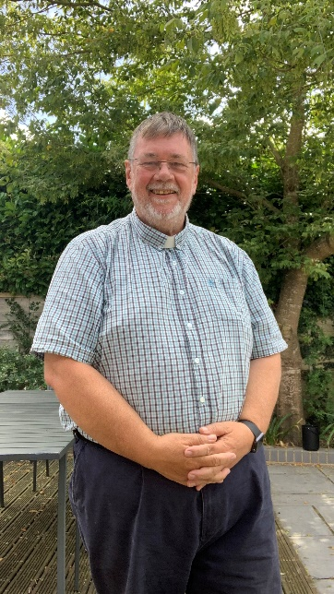
North Downs Deanery
Thank you for considering this post in the North Downs Deanery and the Diocese of Canterbury. We’ve seen some exciting developments across the deanery in the recent past and it is clear that God is on the move here.

There is a real atmosphere of support, encouragement and expectation as we seek to share the Good News of Jesus. At a recent Deanery Synod we spent time sharing stories of good news and the place was buzzing for ages with folk telling of the exciting things happening across the churches here. We heard of growth in numbers – in our informal worship services and in our formal and traditional services. We’ve seen new families and more young people and a growing sense of people going deeper in their relationship with God and each other. We hope you will join us in fostering an atmosphere of collaboration and mission in the area.
Peter Callway,
Area Dean

In our Clergy Chapter you will find a warm welcome and a desire to support one another in prayer and the mission of God. As wee seek God’s will and desire for us individually and collectively we are discerning the way ahead and this is a great time to join us here in semi-rural Kent.

Rest assured I will be praying for this key appointment in North Downs Deanery.

